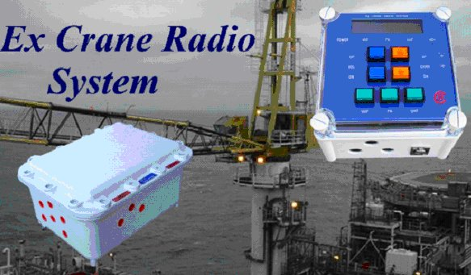

This unit is designed to meet the latest ATEX requirements for hazardous area equipment and is approved for installation and uses in Zone 1 IIB T4 areas.
Although primarily designed for cranes, making it ideal for offshore use, the unit can be utilised in any suitable approved area.

The fully configured system consists of two enclosures, control unit and main unit.

The main unit is an ExD enclosure manufactured in aluminium alloy.
This houses the two radios (VHF, UHF) a universal input mains power supply, interface control electronics and audio output stages, to drive external speakers, and IS barriers.
All cable entries are via 20mm cable glands.

The optional PA is housed in the main unit and comprises of a 25-watt loud hail amplifier, this allows the operator to make announcements to deck personnel.

The control unit consists of a polycarbonate enclosure fitted with a LCD display to indicate channel number and mode, LED indicators to indicate status and push button switches to adjust volume levels and change channels on each radio module. Large push buttons are utilised which can be easily operated even with a gloved hand.

Cable entries to the main unit and foot/hand operated PTT are via 20mm cable glands. Connections to a system approved headset/boom microphone or gooseneck microphone is via a 5-pin connector.
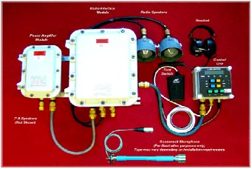

SPECIFICATIONS
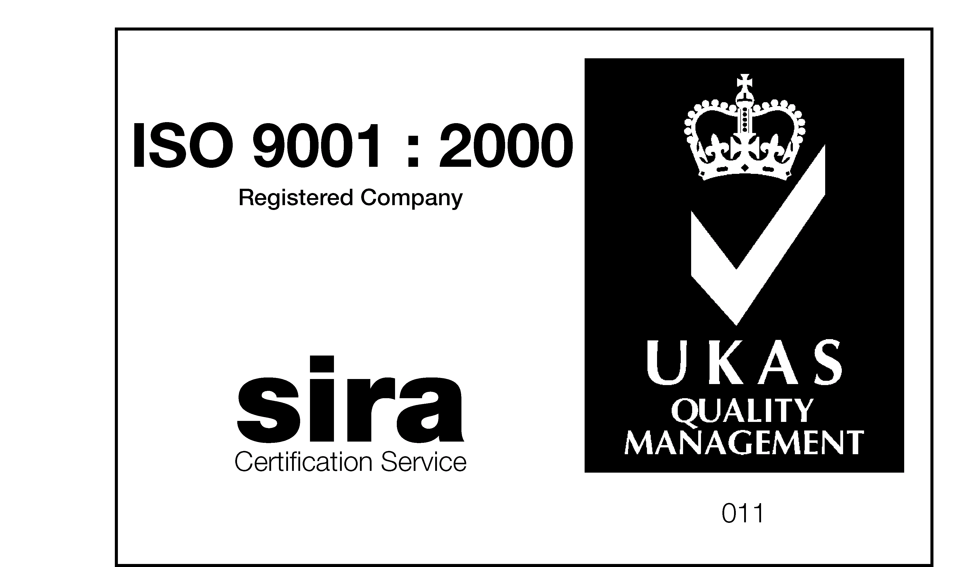


SIRA 03ATEX2404X
0518


Radio Section Freq VHF (136-174MHz, UHF 403-512MHz)

Number of Channels | 16 per radio
Transmitter output | 1 Watt
Channel spacing | +/- 12,5 or 25kHz (specify when order)
Receiver Sensitivity (VHF) | 0.25uv 12dB SINAD
Receiver Sensitivity (UHF) | 0.3uv 12dB SINAD
CTCSS coding on UHF | optional
Audio Output | 5 Watts into External Speaker

PA Section (optional)

Loud Hail Output | 25 watts
Output | 100v Line

Main Enclosure Details

Input Supply | 86-260v AC 65 Watts
Size (Excluding Glands) | 435x330x220
Weight | 22kg (24kg PA Option)
Material | Aluminium Alloy

Control Enclosure

Size (Excluding Glands) | 190x190x130
Weight | 2kg

