BI-DIRECTIONAL TETRA COMBINER

TERA COMBINER 380 – 430 MHz
TYPE 20

Introduction
The Bi-Directional combiner for fixed mobile/portable application allows connection of up to four radios to one antenna.
The unit is designed and built Bi-Directional for transmit and receive paths.
The idea for this combiner is for a low cost; quick setup multiple channel base station application where local command and control communications are required in buildings that have limited space for external antennas.
The combiner can use higher gain antennas whilst defining antenna isolation.
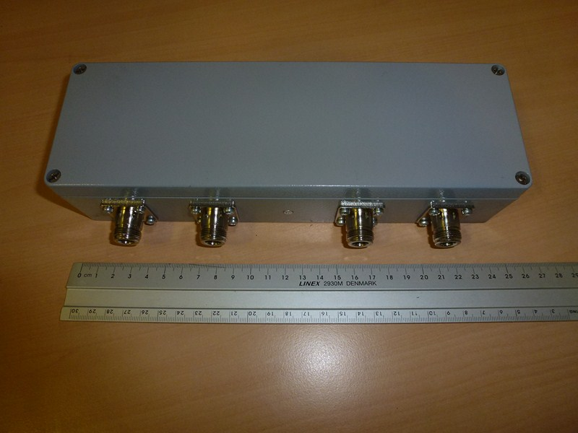

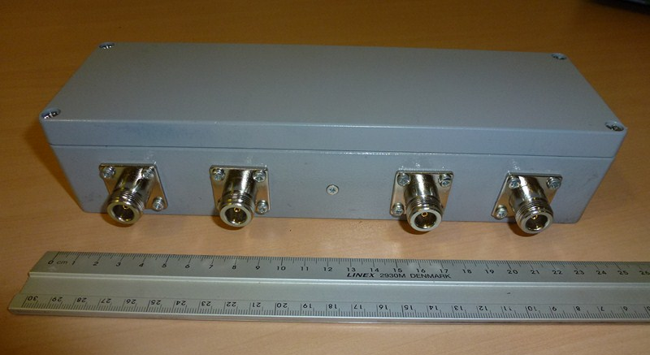
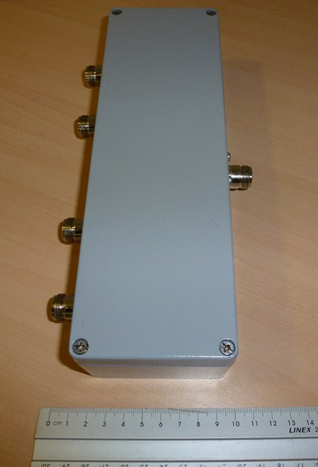

Stats

Detail | Values
Frequency band | 380 – 430MHz
Input Power | 5 Watts / Channel
Tx – Tx Isolation | 25dB
Tx – Aerial Insertion loss | 6.5dB
Connectors | Input N type | Aerial N Type

